Knowledge Organiser Key Stage 3

Subject : Science Year: 7 Topic Title: Energy

Key Facts

- Symbols and Units
  - Energy has the symbol E. The standard unit for energy is joules (J)
  - Time has the symbol t (not capital T). The standard unit for time is seconds (s)
  - Power has the symbol P. The standard unit for power is watts (W)
  - Power is rate of transfer of energy. Calculate power using P=E/t

- There are five main energy stores
  - Kinetic energy is the energy an object has because it is moving.
The faster an object is moving, the more kinetic energy it has.
  - Gravitational potential energy is the energy an object has because it can fall.
The further the object could fall, the more gravitational potential energy it has.
  - Elastic potential energy is the energy an object has because it has been stretched or squashed. The more it has been stretched or squashed, the more elastic potential energy it has.
  - Thermal energy is the energy an object has because of its temperature.
The hotter an object is, the more thermal energy it has (but even objects which are cold to us like ice cubes have some thermal energy).
  - Chemical energy is the energy an object has because of what it is made from.
Some chemicals are used as fuels for vehicles (such as gas or petrol) or fuels for us (food and drink).

- There are four ways that energy can be transferred
  - mechanically (when a force causes an object to move)
  - electrically (when a potential difference causes charges to move)
  - by heating (when there is a difference in temperature)
  - by radiation (when waves transfer energy e.g., by light or sound waves)

- Energy supplied to your house costs money.
  - first work out how many kW of energy has been transferred (1kW = 1000W)
  - next work out how many hours this power has been transferred for
(1 hour = 60 minutes = 3600 seconds)
  - multiply kW x hours to work out the energy transferred in kWh.
kWh is a non-standard unit for energy used on your electricity and gas bill.

Key words & definitions

- The law of conservation of energy - energy cannot be created or destroyed, only transferred or stored
- Conduction - thermal energy transfer through a solid by vibrating particles
- Convection - thermal energy transfer through a fluid (solids + gases) by moving particles
- Radiation – thermal energy transfer from by waves of energy
- Fuel – chemical energy source (usually for burning)
- Appliance – a device or piece of equipment (often electrical) designed to perform a task
- Renewable - energy source that can be continually replaced (e.g., wind, solar, tidal, hydroelectric, wave, geothermal)
- Non-renewable - energy source that cannot be replaced (e.g., coal, oil, gas, nuclear fuel)
- When energy is transferred, work is done. Work done has the same unit as energy – joules (J)
- Work done = Force x distance

Diagrams
useful energy out
energy in
wasted energy out
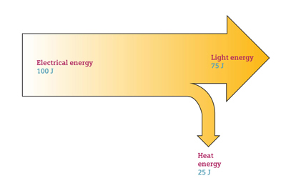

Potential misconceptions to avoid / errors students often make

  - Never say that energy is used! If an energy store has lost energy, this energy has been transferred to another store – often the thermal store of the air
  - Energy cannot be used, but it can be useful – what is useful energy depends on what you want from the appliance e.g., you want a fan to move (kinetic) but not get hot (thermal)
  - Energy tends to spread out and become less useful e.g., hot objects eventually cool down

